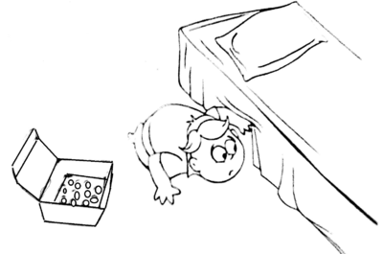

1) Tattu has 25 marbles with him in a box. He accidentally dropped the box and all the marbles got scattered on the floor. He somehow managed to find 18 marbles. How many more are missing?

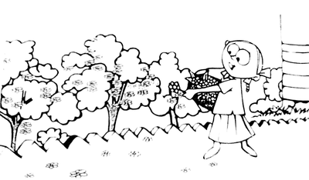
2) Rina is picking flowers in the garden. There are 25 jasmine flowers in the plant and 8 have fallen on the ground. How many flowers are there in total?

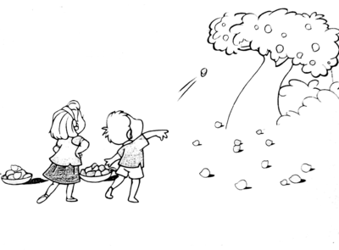

3) Praveen and Ram were plucking mangoes from a tree and collected 31 mangoes. Ram got 13 mangoes, so how many mangoes has Praveen got?

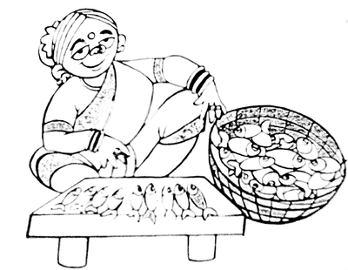

4) Meenamma has 26 fishes in total. There are 9 on the stone table. How many does she have in her basket?

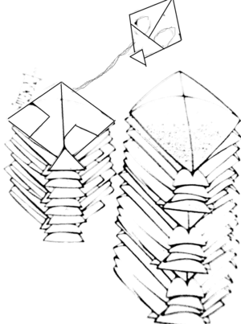

5) Kites in a shop have been arranged in two piles. The larger pile has 24 kites and the smaller pile has 12 kites. How many kites are there in all?

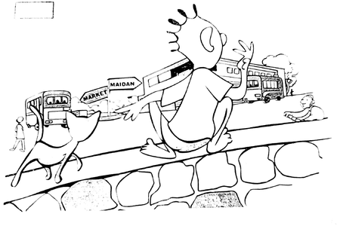

6) Arun is watching buses at the bus depot. There are 15 buses going towards the market and 17 buses going towards the maidan. How many buses would Arun count in total?

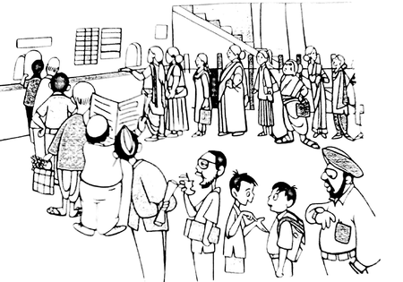

7) In a cinema theater, 19 men and 14 women are standing in separate lines to buy tickets. So how many people in total are waiting to buy tickets?

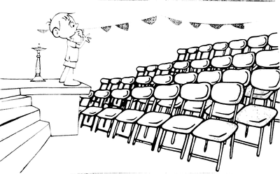
8) Rahim was counting the number of chairs that have been arranged for a programme. There were some coloured chairs and some white chairs and in total there were 45 chairs. He then counted only the white chairs and found that there were 19 white chairs. So, how many coloured chairs were there?

