English Baseline Test (Written Part) 30 minutes

- Listen to the alphabet sound and write the corresponding alphabet 5 min

The sounds are played to the whole class and students write the alphabet they hear; the same sounds they heard earlier.

Rubrics

The objective here is to see how familiar students are with the script and if they are able to reproduce script. If students have not been able to identify the script after listening to the sounds, they will not be asked to write.

Levels of performance
1. Does not know/ not asked to write
2. Familiar with less than 10 sounds and able to write associated script
3. Familiar with 10-20 sounds and able to write associated script
4. Familiar with all the sounds and able to write associated script
To be marked as 1 /4 or 2/4 etc

- Read the simple sentences and match with the correct pictures.

Rubrics

The objective here is to understand reading fluency as well as comprehension by identifying the associated picture. If the student could not read in Q 9, this question is not to be attempted.

Levels of performance
1. Does not read the sentence
2. Reads but does not comprehend – does not attempt to match the pictures
3. Reads and matches

To be marked as 1 /3 or 2/ 3 etc

- Fill in the missing letters to form the words
m _ t | s t a _
p o _ | _ i l k
b _ n | t _b l e
c a _ | a p p _ e
h _ n | c _ c le
p i _ | p h _ n e
_ u t | t _ a i n
l _ m p | p l a _ e

Rubrics
The objective here is to see how students can see writing as a purposeful activity to communicate and also demonstrates script familiarity as well as some level of vocabulary.

Levels of performance
1. Does not write/ cannot comprehend the activity
2. Completes less than 5 words
3. Completes 5 – 10 words
4. All words are completed

To be marked as 1 / 4, 2/4 etc

- See the picture below and write all the words you know (picture on next page)
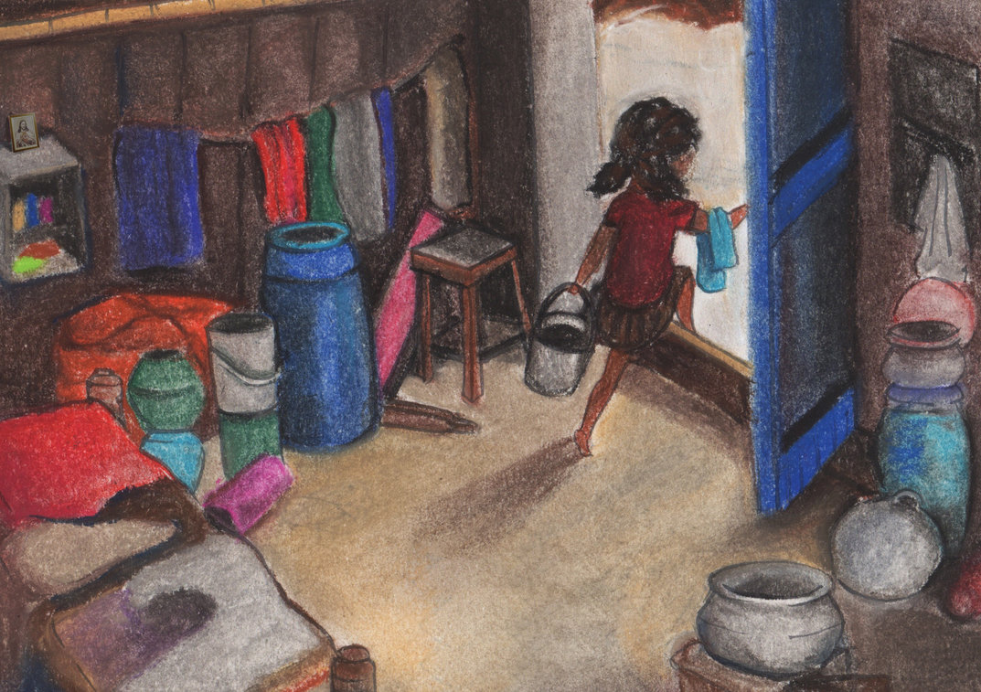

Rubrics
The objective here is to see how students can see writing as a purposeful activity to communicate and also demonstrates script familiarity as well as some level of vocabulary.

Levels of performance
1. Does not write/ cannot comprehend the activity
2. Completes less than 5 words
3. Completes 5 – 10 words
4. Able to write more than 10 words
To be marked as 1 / 4, 2/4 etc

- See the picture and make a story with pictures and words. . 10 min

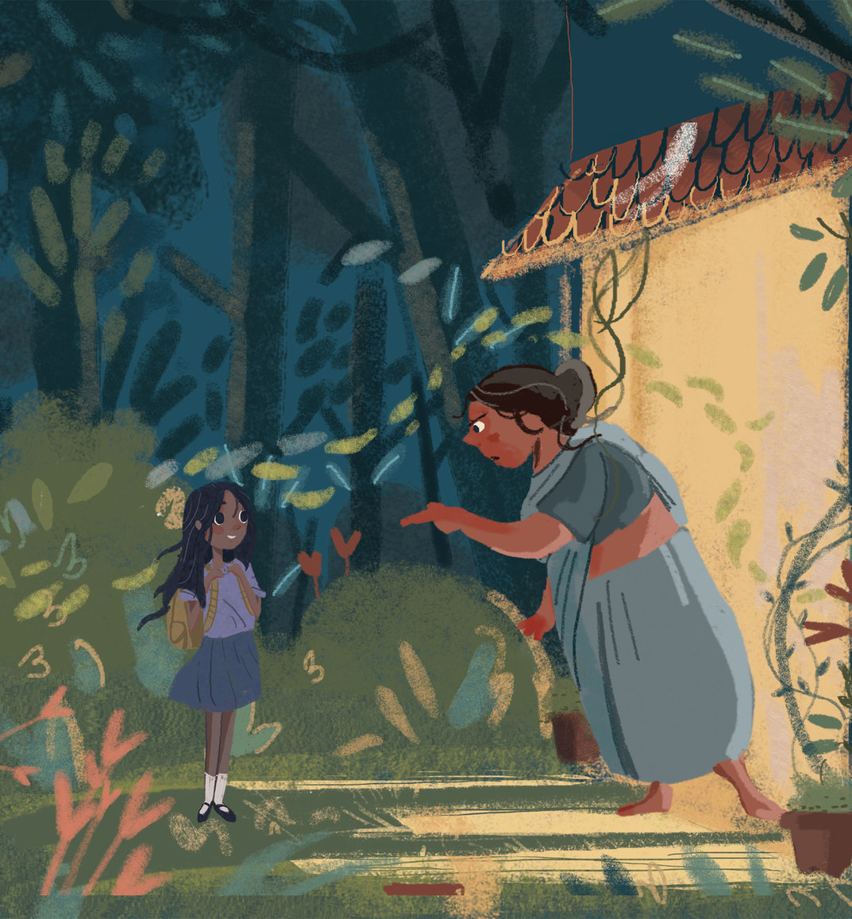
Rubrics
The objective here is to see how students can see writing as a purposeful activity to communicate and also demonstrates script familiarity as well as some level of vocabulary. Their ability to think complex plots as well as their ability to express in meaningful sentences, coherently is to be assessed. Spelling and grammar errors, while to be noted, are not to be penalized. At this stage, writing serves as an impetus for further reading. Writing can include pictures (where the student can draw a picture instead of a word if their vocabulary is not there). Story can be bilingual.

Levels of performance
1. Does not write/ cannot comprehend the activity
2. Is able to write a simple story with 1-2 sentences; could be partly formed along with pictures, in first language only
3. Is able to write a simple story with 1-2 sentences; could be partly formed along with pictures, in English combined with first language
4. Is able to write a paragraph with rich details – can be bilingual and with pictures instead of words but the attempt is primarily in English
5. Is able to write a paragraph in English describing the story

