Theme : Wellbeing 2

Sub-theme / Topic | CHILDREN’s time on task  40 - 45 minutes session
Objective  FOr CHILDREN:  - recognize and visualize positive characteristics in them. | Duration of task/activity/lesson  1 day - 1 session
Phase 1: Before the task begins
Your Preparation for the Task:  Do the activity yourself before the session and think of the possible responses that students might have. | will there be any Parent engagement required for it:  Yes (optional)  Students can talk to their parents if they are struggling to identify their positive characteristics on their own.
What preparation/material/device would CHILDREN need for this task?  -Access to WhatsApp/Google Meet  -A journal and basic stationery | How will you share the task/activity/lesson? (Medium)  WhatsApp message + audio
How you expect CHILDREN to share back?  Children can share their insights/work through whatsapp or google meet. | Day of the week to send instruction  TBD by facilitator
Instruction you will send out (write a crisp instruction  )  Trigger Question:  Ask children to think of one good thing that happened the day before.  Encourage them to share their thoughts with the group if they are comfortable.  You can share your response to the question with children.  Introduce the idea of looking for positives. Explain that thinking positively or negatively (being optimistic/pessimistic), can become a habit and can affect your mood and levels of happiness. Describe how sometimes we can all get in the habit of noticing the negative stuff more than the positive, and this activity helps to rebalance this.  Instructions for activity:  Step 1  Give out the template (as shown in the picture below) and explain that they need to write some words in each shape, e.g. I have people around me.  I trust and who loves me, I am a good friend, I can ask for help when I need it. They can write 2 or 3 per shape and think about how each one makes them feel.  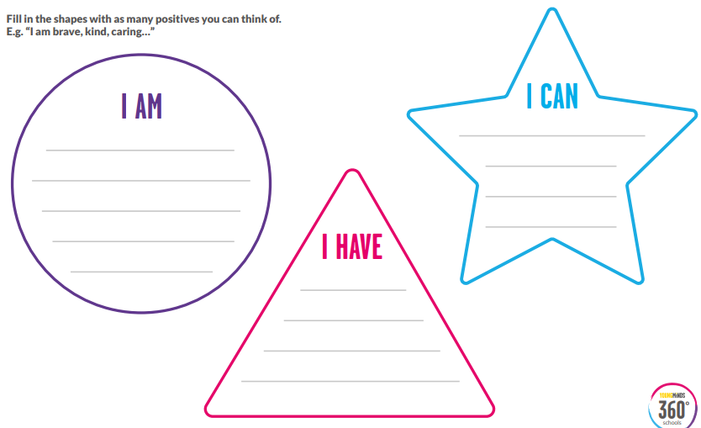  Step 2  Share some of your own characteristics with the group, explaining how each one makes you feel. If any student volunteers to share one of theirs, allow them to do it.  Ask the children to keep their sheets safe and to remind themselves of their assets regularly.  Revisit this activity after some time so that children can add to their list of assets. | Day of the week to close TASK  To be closed on the first session  You could revisit this activity over time by asking the children to add to the list of assets.
Phase 2: During the task
Trigger / prompts to support children  Summarize -  Tell students that regular negative thoughts can become a habit and can affect our overall mood and levels of happiness. Therefore it is important to remind ourselves everyday of all the positives - We Have, We Are and We Can!!  Check with students how they are feeling after the session and encourage them to continue to do this activity at least once a week. | Other notes  Many students may struggle to think positively especially during this pandemic. This simple activity will help students to visualise and recognise positive characteristics in themselves.
Phase 3 – After the task is over
How do you plan to close the task?  Thank students for taking part in the session. Tell them about the next class. Convey thanks to parents for letting their children use mobile phones and encourage them to participate in the coming sessions. | Recognition for CHILDREN to acknowledge their work, effort, response etc. (if any, need not build it every time)
REFLECTIONS (what went well, what didn’t go well, anything you want to change)

