C01 - Geogebra

Activity 1. Introducing Geogebra
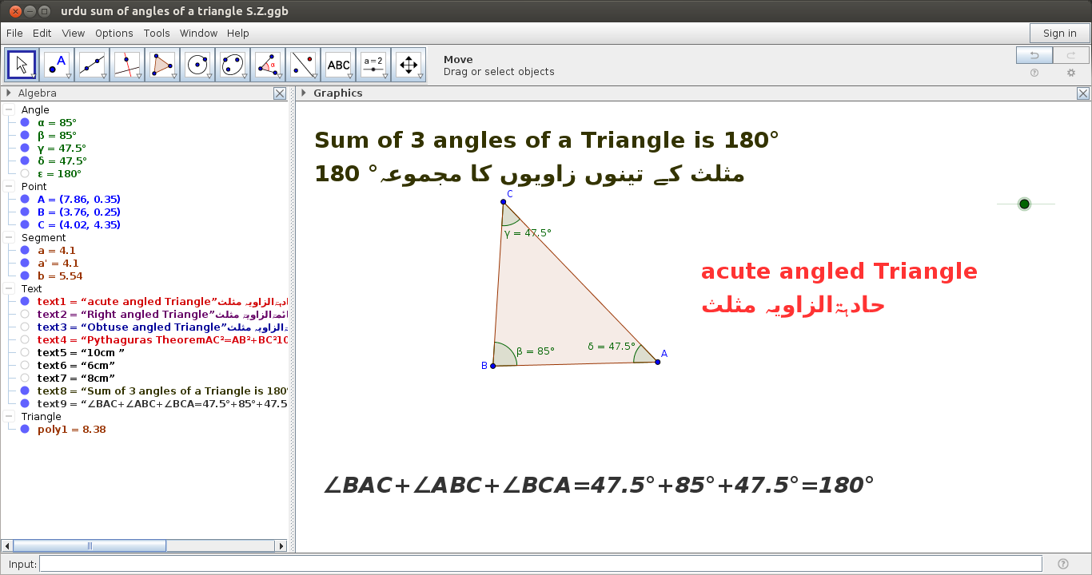
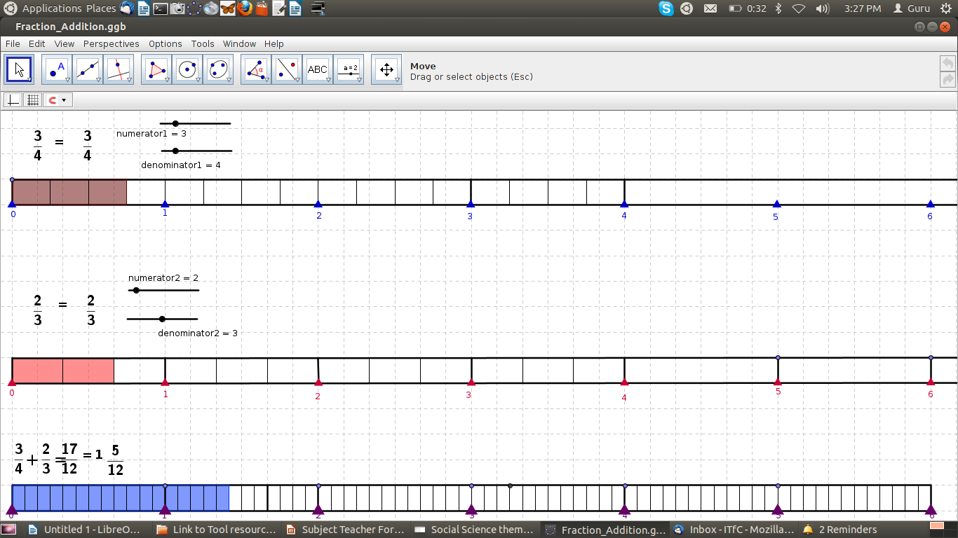
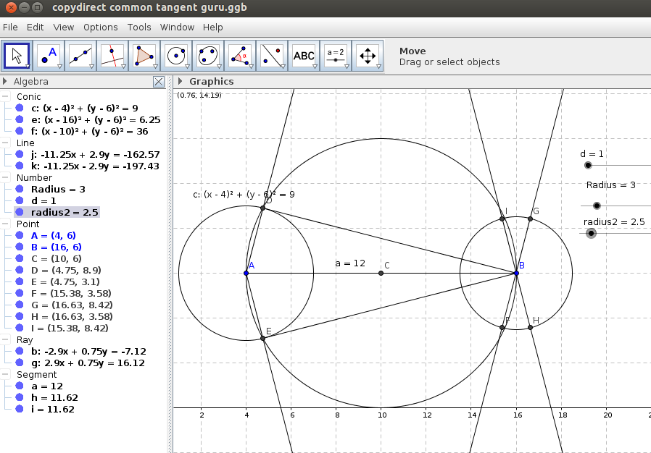 | 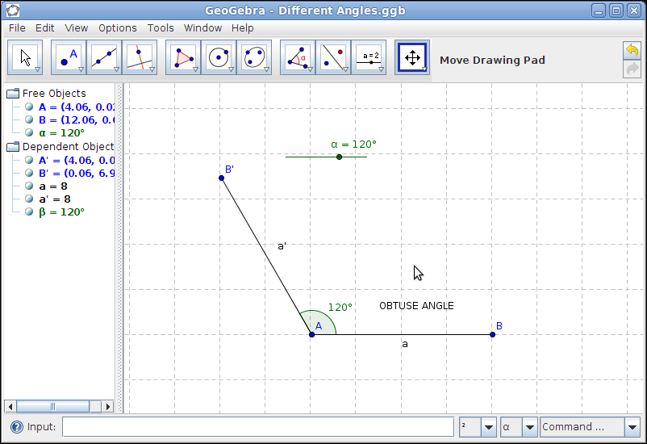

Geogebra is a free educational application which enables a teacher to create lessons which can be used for Mathematics teaching-learning. Geogebra combines geometry and algebra to create visual representations of different concepts and can be used to create interactive resources.
Geogebra allows you to make sketches on a graphic view and the algebra pane describes the co-ordinates of the construction. Functions can be defined using the input bar. It is possible to animate constructions in Geogebra by defining the variable as a slider. Geogebra also allows instructions to be typed in Indic languages. The tool also has a spreadsheet option to work with list values for plotting a function.

Why Geogebra
Teachers can use it as an interactive construction board in the classroom or as stand alone resource for demonstration and student learning. It can also be used for assessments.

Additional resources
- The Geogebra software can be downloaded freely from http://sourceforge.net/projects/Geogebra and it is available on GNU/Linux and Windows platforms.
- Geogebra respository of files is available as Open Educational Resources on http://Geogebratube.org.
- https://www.geogebra.org
- Video tutorials of Geogebra are available in several languages, see
  - http://spoken-tutorial.org/tutorial-search/?search_foss=Geogebra&search_language=English
  - http://spoken-tutorial.org/tutorial-search/?search_foss=Geogebra&search_language=Hindi

Activity 2. Introduction to angles
In this activity we will take up a small exploration of angles as a geometric concept with the use of Geogebra. The objectives of this activity are as follows:
- To get introduced to the interface of Geogebra and basic features and to be able to make sketches
- To appreciate the pedagogic possibilities of using Geogebra in the classroom
- To introduce different kinds of angles and angle pairs to students
Resources used:
- Introduction to angles.ggb
- Introduction to types of angles.ggb

Lesson
- Step 1: Open the Geogebra application, when you open it you will see a window like this.
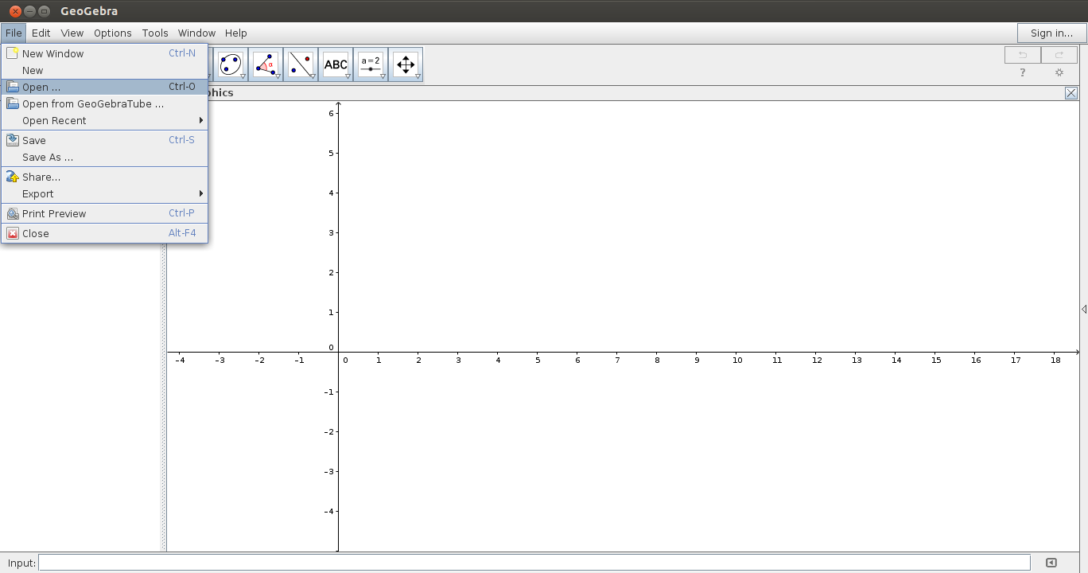
- From the File Menu open the attached Geogebra file called Introduction to angles.ggb In the tool bar, in the left most corner, you will find an arrow. This arrow can be used to move around the construction objects in the Geogebra.
- Step 2: Select the arrow button and then select one of the points and move it around. You would have noticed that the angle formed changes. This can be used to discuss how angles are formed and measured . Discuss with your fellow teachers if “BAC” or “CAB” refer to the same angle? Using the angle measurement tool, measure the angles in the order mentioned above and determine the difference between clockwise and counter clockwise measurements of angles
- Step 3: Plot a point, draw two segments and measure the angle. Draw two lines and measure the angle between them when they intersect. Label the angles. Explore different ways of formatting lines and angles. Save the file. Using a textbox write a definition of an angle.

Tip
To perform the steps discussed above, view the ‘Learn Geogebra’ web page here

Peer Review:
How is the activity useful for student learning.
For instance, you could extend the length of the segment and ask the students to comment on whether the angle size is changing or not.

Activity 3: Introduction to triangles
In this activity we will explore types of angles as an example for creating a dynamic sketch in Geogebra. This activity will includes an introduction to triangles.
The objectives of this activity are:
- To get introduced to the interface of Geogebra and basic features
- To appreciate the pedagogic possibilities of using Geogebra in the classroom
- To introduce different kinds of angles and demonstrate the possibility of creating a dynamic resource
- To introduce triangles as a structured exploration from lines and angles
Resources used:
- 2. Types of angles.ggb
- 3a.Introduction to triangles.ggb
- 3b.Introduction to triangles.ggb
Lesson
- Step 1: We will learn an important feature of Geogebra called the slider – which allows the resource to be animated. For example, when you introduce angles, types of angles is one common learning objective. It will be useful to have the type of the angle displayed based on the value of the angle. Open the file called Introduction to types of angles.ggb. You will learn how to construct a similar file; this file uses a feature called a slider to change the value of the angle. The type of the angle is displayed using a textbox which displays the appropriate type of angle based on the value of the angle. The slider is basically a variable and can either be for a number or an angle. Here we have used the angle slider. Click here for a description of how to build the slider : https://teacher-network.in/OER/index.php/Learn_Geogebra#Using_the_tool_bar_-_slider
- Step 2: Make an angle using a slider. First define a slider and use the “angle with given size” option from the tool bar to define an angle based on the slider. Join the vertex with the rotated point and you will get the new angle. Use the textbox to write the text with the type of angle. Once the textbox is defined, use the Object Properties to change the color, format and also to make the display conditional based on the value of the slider.
- Step 3: Open the file called 5a.Introduction to triangles.ggb and explore how the lesson is being developed on a basic introduction to triangles
  - The triangle is being introduced as a bounded figure made by three lines. The lesson starts with an introduction to lines and angle and you can explore how the triangle is formed.
  - Study the segments formed by the intersection of the lines.
  - Changing and moving the lines allows you to verify and generalize the angle sum property.
- Step 4: Open the file called 5b.Introduction to triangles.ggb. This further extends the ideas of angles in a triangle building on the previous activity.
In both these files, check boxes are used as a method of controlling/ prompting the lesson, questions. Each item of construction can be linked to a check box and can be shown when needed for discussion.
- Step 5: Construct a triangle. Use the measure angle and measure length tool to measure angles and segments. Make a table exploring the connection between the angle measure and side length. Use a check box to display the measurements. Write your notes about the features of sides and angles of a triangle in a text box in the file. Save the file as ‘<my name> Learning triangles.ggb’. Email your file to your team member and seek her/his comments.

Tip
To perform the steps discussed above, view the ‘Learn Geogebra’ web page here

Peer Review:
- Discuss with your team member (using the discussion forum) what a triangle is and what are the different properties associated with a triangle
  - Angle sum property
  - Relationship between side and angle
  - Exterior angles and interior angles
Share your comments on the files shared by your team member
Finally, you can take a look at some of these sample geogebra files:
Real Numbers
Pair of Linear Equations in Two Variables
Coordinate Geometry
Similar Triangles

Quiz

Geogebra can be used online only. (True/ False)
Geogebra can be used for - creating constructions, demonstrating problems, making interactive lessons (check all that apply)
Angles can be measured in geogebra in the following directions - clockwise, counter clockwise, either (check all that apply)
Geogebra files can be saved and used in the following ways – image, geogebra (.ggb), HTML, applets published on geogebra.org, <http://geogebra.org> (check all that apply)
5. The following tool is used for building animation in Geogebra - slider, textbox, check box, input bar (radio button)
Geogebra can be used to construct two dimensional and three dimensional figures. (True or False)
View the following geogebra file (Radha angles of triangle) and discuss in telegram group how the lesson can be conducted in class
Create a geogebra sketch of one of the following – square, rectangle or parallelogram - and upload. Share your experiences of construction

